## A1 - New Zealand’s biosecurity system[1]

The biosecurity system involves government, industry, Maori and all New Zealanders working together to manage risks posed by pests and diseases to the economy, environment and human health.

The biosecurity system is based on risk management activities undertaken across a range of inter-related areas – pre-border, at the border and post-border. Some of the activities and outcomes in each layer are described below.

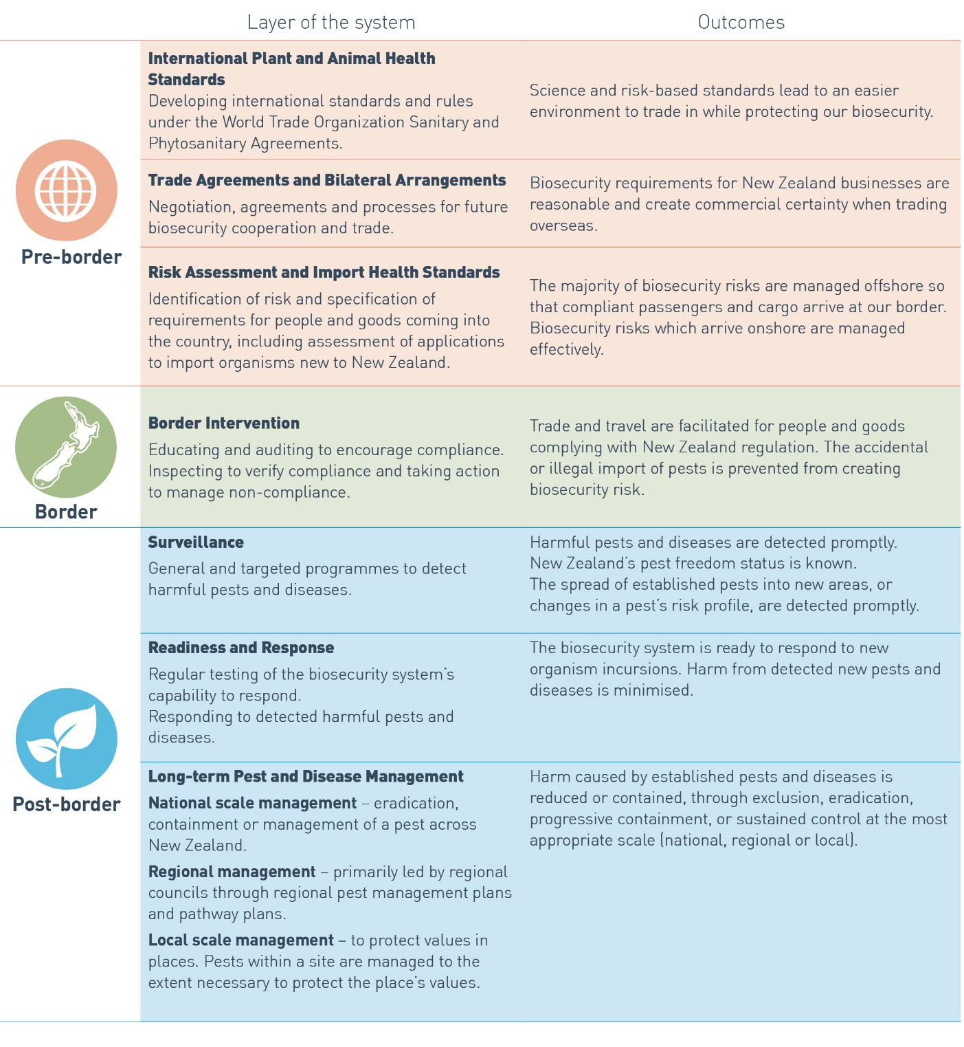

1. As presented in the *Biosecurity 2025 Direction Statement for New Zealand’s biosecurity system*